**UseCase1**: Buy the Game

**Primary Actor**: Real-time Player

**PreCondition**: Player has to be logged/ has the title screen to play the game

**Main Success Scenario**: Player is able to play the game software booted up perfectly without any crashes, or glitching preventing the user from playing.

Game shows the software it is designed on. AutoDesk Scaleform

Software allows the user to play the game

**Exception Scenarios**:

There are no previous saved games in the software allowing the user to play from scratch.

Marvel's Avengers is a 2020 action role-playing brawler video game developed by Crystal Dynamics and published by Square Enix's European subsidiary.

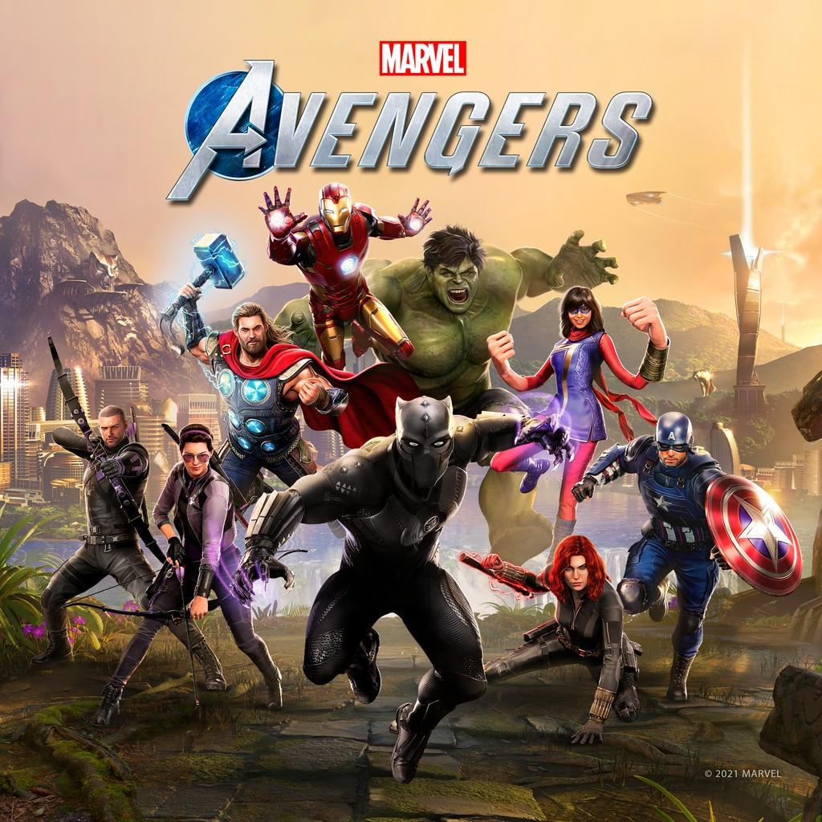

**DEVELOPER:** Crystal Dynamics

**PUBLISHER:** Square Enix

**SERIES:** *An original Cinematic Story*

**GENRES:**Action, third-person, adventure, Brawler

**RELEASE DATE(S)**:US: Sep, 22, 2021

**NUMBER OF PLAYERS:** 1 player for story campaign,1-4 for Avengers Initiative

**Gameplay**

Marvel's Avengers is a third-person, action-adventure game that combines an original, cinematic story with single-player and co-operative gameplay. The game features a unique combat system chaining attacks, dodges, abilities, skills and elements to succeed a combat phase.

The game can be played offline as a single-player experience or online with up to four people during certain aspects of the game. The game will feature customization options including abilities and costumes, which can be upgraded using a skill tree. Costumes have been sourced from "all corners of the Marvel universe" and can be earned in-game or bought separately as DLC. Players will also be able to receive free updates containing new regions and characters.

By this information, I think I can accomplish the software process, because this needs very intricate detailing to the artwork, and picture display. Mostly, CD use AutoDesk ScaleForm.